Screenshots of running Program

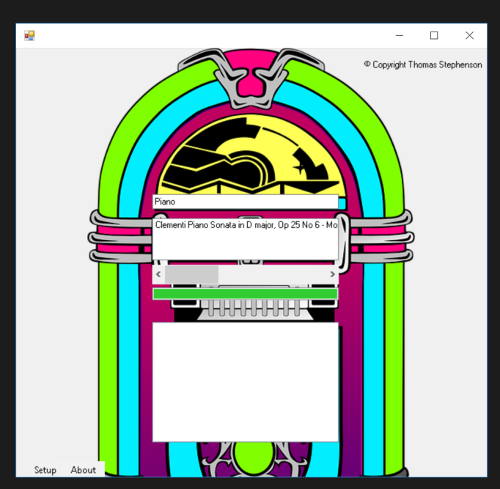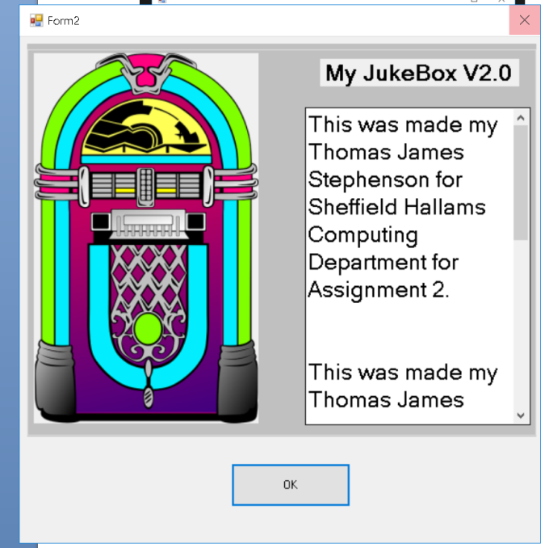

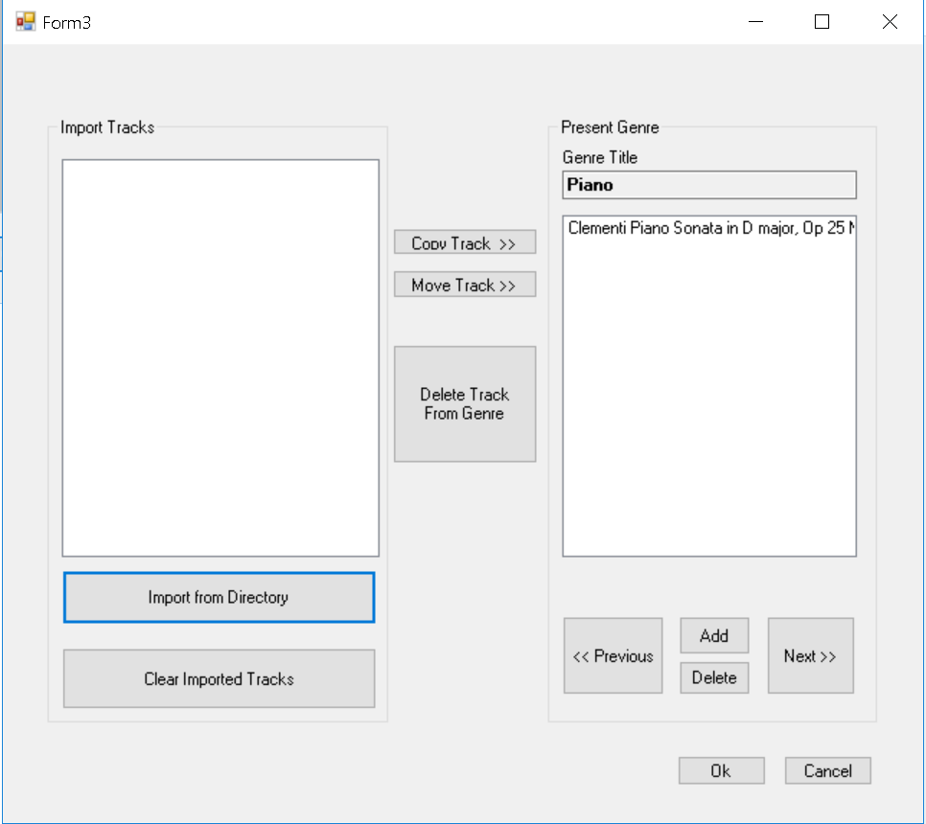

Github Link

https://github.com/stevot1995/Jukebox-Version-2

Code for Main

using System;

using System.IO;

using WMPLib;

using System.Collections.Generic;

using System.ComponentModel;

using System.Data;

using System.Drawing;

using System.Linq;

using System.Text;

using System.Threading.Tasks;

using System.Windows.Forms;

namespace WindowsFormsApp3

{

public partial class Main : Form

{

ListBox[] Genre;

WMPLib.WindowsMediaPlayer play = new WMPLib.WindowsMediaPlayer();

string TrackPath = Directory.GetCurrentDirectory() + "\\Tracks\\";

int selected_genre;

public Main()

{

InitializeComponent();

}

// Cant delete this as it breaks my program!!, not sure that it does anything?!?! //

private void Main_Load(object sender, EventArgs e)

{

}

// Opens the Setup form. //

private void toolStripMenuItem1_Click(object sender, EventArgs e)

{

var Setup = new Setup();

Setup.Show();

}

// Opens the About form. //

private void toolStripMenuItem2_Click(object sender, EventArgs e)

{

var About = new Info();

About.Show();

}

// Loads the form data and interger values of events into the jukebox //

private void Load_data(object sender, EventArgs e)

{

int TotalNumberofGenre;

int Tracks;

// This gets the location where the media folder directory is located.

string applicationPath = Directory.GetCurrentDirectory() + "\\Media\\";

// Reads a file on the HDD in the subfolder "media" called "Media.txt"//

StreamReader myInputStream = File.OpenText(applicationPath + "Media.txt");

// Obtains the files contents and converts it into a interger. //

TotalNumberofGenre = Convert.ToInt32( myInputStream.ReadLine());

// Sets the scroll bar to start scrolling between genres 0-3. //

hScrollBar1.Maximum = TotalNumberofGenre -1;

//Creates a new listbox which is equal the the total number of Genres (3) //

Genre = new ListBox[TotalNumberofGenre];

// Adds tracks into the Genres in the listbox //

for (int G = 0; G < TotalNumberofGenre; G++)

{

Tracks = Convert.ToInt32(myInputStream.ReadLine());

Genre[G] = new ListBox();

Genre[G].Items.Add(myInputStream.ReadLine());

for (int t = 1; t <= Tracks; t++)

{

Genre[G].Items.Add(myInputStream.ReadLine());

}

}

// Closes the file and also resets the display genre to 0 //

myInputStream.Close();

display_genre(0);

}

// Displays the genre in the textbox //

private void display_genre(int G)

{

selected_genre = G;

Txt_title.Text = "";

listBox2.Items.Clear();

Txt_title.Text = Genre[G].Items[0].ToString();

for (int t = 1; t < Genre[G].Items.Count; t++)

{

listBox2.Items.Add(Genre[G].Items[t].ToString());

}

}

// Scroll bar obtains the value to scroll from the display genre //

private void hScrollBar1_Scroll(object sender, ScrollEventArgs e)

{

display_genre(hScrollBar1.Value);

}

// Allows the songs to be selected and play //

private void listBox2_SelectedIndexChanged(object sender, EventArgs e)

{

play.URL = TrackPath + Genre[selected_genre].Items[listBox2.SelectedIndex +1].ToString();

play.controls.play();

}

// Double click adds the song to the Queue listbox and Now playing listbox below //

private void Queue_song(object sender, EventArgs e)

{

{

int c = listBox2.Items.Count - 1;

for (int t = c; t >= 0; t--)

{

if (listBox2.GetSelected(t))

{

listBox1.Items.Add(listBox2.Items[t]);

listBox3.Items.Add(listBox2.Items[t]);

}

}

}

}

}

}

Code for Setup

using System;

using System.IO;

using System.Collections.Generic;

using System.ComponentModel;

using System.Data;

using System.Drawing;

using System.Linq;

using System.Text;

using System.Threading.Tasks;

using System.Windows.Forms;

namespace WindowsFormsApp3

{

public partial class Setup : Form

{

ListBox[] Genre;

string TrackPath = Directory.GetCurrentDirectory() + "\\Tracks\\";

int selected_genre;

public Setup()

{

InitializeComponent();

}

string[] Folderbrowser, MP3;

public void button1_Click(object sender, EventArgs e)

{

if (openFileDialog1.ShowDialog() == DialogResult.OK)

{

Folderbrowser = openFileDialog1.FileNames;

MP3 = openFileDialog1.SafeFileNames;

for (int M = 0; M < MP3.Length; M++)

{

listBox1.Items.Add(MP3[M]);

}

}

}

public string ListofSongs

{

get { return listBox2.SelectedItem.ToString(); }

}

private void openFileDialog1_FileOk(object sender, CancelEventArgs e)

{

}

private void Form3_Load(object sender, EventArgs e)

{

int TotalNumberofGenre;

int Tracks;

// This gets the location where the media folder directory is located.

string applicationPath = Directory.GetCurrentDirectory() + "\\Media\\";

// Reads a file on the HDD in the subfolder "media" called "Media.txt"//

StreamReader myInputStream = File.OpenText(applicationPath + "Media.txt");

// Obtains the files contents and converts it into a interger. //

TotalNumberofGenre = Convert.ToInt32(myInputStream.ReadLine());

//Creates a new listbox which is equal the the total number of Genres (3) //

Genre = new ListBox[TotalNumberofGenre];

// Adds tracks into the Genres in the listbox //

for (int G = 0; G < TotalNumberofGenre; G++)

{

Tracks = Convert.ToInt32(myInputStream.ReadLine());

Genre[G] = new ListBox();

Genre[G].Items.Add(myInputStream.ReadLine());

for (int t = 1; t <= Tracks; t++)

{

Genre[G].Items.Add(myInputStream.ReadLine());

}

}

// Closes the file and also resets the display genre to 0 //

myInputStream.Close();

display_genre(0);

}

// Displays the genre in the textbox //

private void display_genre(int G)

{

selected_genre = G;

Txt_title.Text = "";

listBox2.Items.Clear();

Txt_title.Text = Genre[G].Items[0].ToString();

for (int t = 1; t < Genre[G].Items.Count; t++)

{

listBox2.Items.Add(Genre[G].Items[t].ToString());

}

}

// Scroll bar obtains the value to scroll from the display genre //

private void hScrollBar1_Scroll(object sender, ScrollEventArgs e)

{

display_genre(hScrollBar1.Value);

}

// Clears the items in listbox1 //

private void button2_Click(object sender, EventArgs e)

{

listBox1.Items.Clear();

}

// Allows the items to be copied when selected to listbox1 //

private void button3_Click(object sender, EventArgs e)

{

Copy();

}

private void Copy()

{

int c = listBox1.Items.Count - 1;

for (int t = c; t >= 0; t--)

{

if (listBox1.GetSelected(t))

{

listBox2.Items.Add(listBox1.Items[t]);

}

}

}

// Allows the items to be added to the listbox on selection //

private void button4_Click(object sender, EventArgs e)

{

Add();

}

private void Add()

{ int a = listBox1.Items.Count - 1;

for (int i = a; i >= 0; i--)

{

if (listBox1.GetSelected(i))

{

listBox2.Items.Add(listBox1.Items[i]);

listBox1.Items.RemoveAt(i);

}

}

}

private void listBox2_SelectedIndexChanged(object sender, EventArgs e)

{

}

private void openFileDialog1_FileOk_1(object sender, CancelEventArgs e)

{

}

// Allows items to be deleted when selected //

private void button5_Click(object sender, EventArgs e)

{

if (listBox2.SelectedItems.Count != 0)

{

while (listBox2.SelectedIndex != -1)

{

listBox2.Items.RemoveAt(listBox2.SelectedIndex);

}

}

if (listBox1.SelectedItems.Count != 0)

{

while (listBox1.SelectedIndex != -1)

{

listBox1.Items.RemoveAt(listBox1.SelectedIndex);

}

}

}

// Closes the form//

private void button10_Click(object sender, EventArgs e)

{

this.Close();

}

// Closes the form//

private void button11_Click(object sender, EventArgs e)

{

this.Close();

}

//Moves the genre to the next one //

private void button9_Click(object sender, EventArgs e)

{

display_genre(hScrollBar1.LargeChange);

}

// Moves the genre to the previous one //

private void button6_Click(object sender, EventArgs e)

{

display_genre(hScrollBar1.SmallChange);

}

// Allows items to be deleted when selected //

private void button8_Click(object sender, EventArgs e)

{

if (listBox2.SelectedItems.Count != 0)

{

while (listBox2.SelectedIndex != -1)

{

listBox2.Items.RemoveAt(listBox2.SelectedIndex);

}

}

if (listBox1.SelectedItems.Count != 0)

{

while (listBox1.SelectedIndex != -1)

{

listBox1.Items.RemoveAt(listBox1.SelectedIndex);

}

}

}

//Adds item from imported directory//

private void button7_Click(object sender, EventArgs e)

{

Add();

}

private void listBox1_SelectedIndexChanged(object sender, EventArgs e)

{

}

}

}

Code for About

using System;

using System.Collections.Generic;

using System.ComponentModel;

using System.Data;

using System.Drawing;

using System.Linq;

using System.Text;

using System.Threading.Tasks;

using System.Windows.Forms;

namespace WindowsFormsApp3

{

public partial class Info : Form

{

public Info()

{

InitializeComponent();

}

private void buttonOK_Click(object sender, EventArgs e)

{

this.Close();

}

private void label1_Click(object sender, EventArgs e)

{

}

private void textBox1_TextChanged(object sender, EventArgs e)

{

}

}

}